**-XX:+UseParallelGC -Xmx12m -Xms12m -Xlog:gc:log_Parallel.txt:time,level,tags**

Добавил 250000 элементов

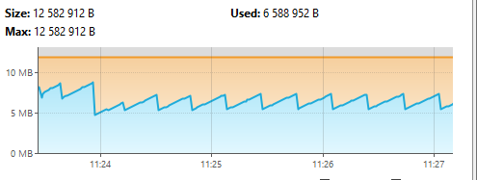

Наблюдаем рост до 7600 и сборка

Массив int после добавления 250000

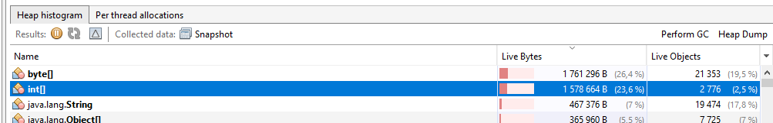

**Слияние (**MergeSort**)**

Рост массива

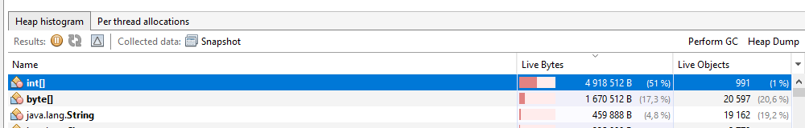

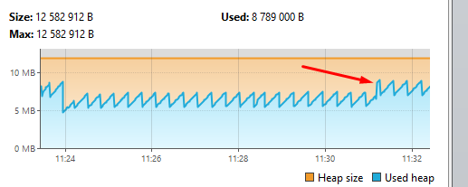

Массив после сборок

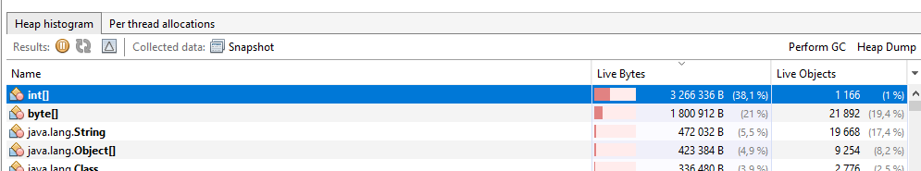

Время сортировки 20мс

MergeSort Начало сортировки 11:31:09.573090200

MergeSort Конец сортировки - 11:31:09.781081800

**Вставка**

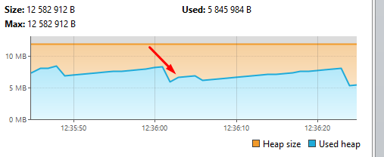

Размер массива

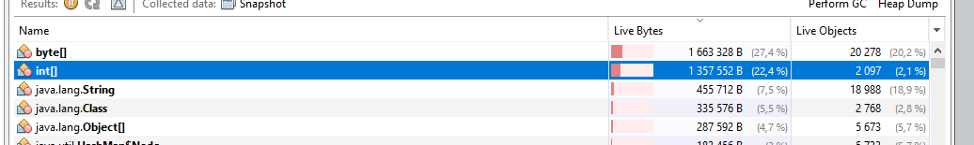

Время сортировки 10сек

InsertSort Начало сортировки - 12:36:01.242131600

InsertSort Конец сортировки - 12:36:11.182144500

**Пузырьком**

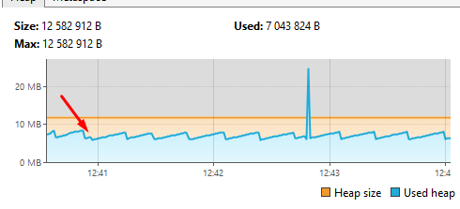

График процессора

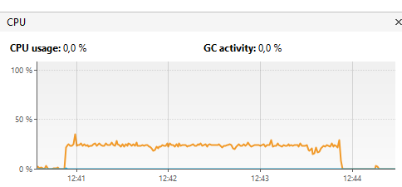

Создание клона массива

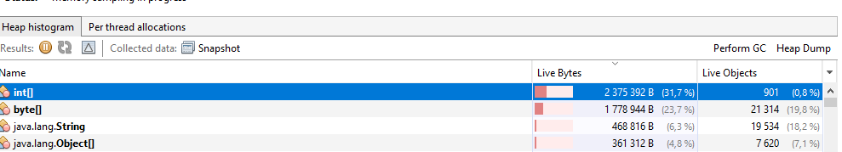

Время сортировки 3мин

BubbleSort Начало сортировки - 12:40:52.092516900

BubbleSort Конец сортировки - 12:43:50.748511

**-XX:+UseG1GC -Xmx12m -Xms12m -Xlog:gc:log_G1.txt:time,level,tags**

Сбор мусора выполняется редко. Что и видим на графике

Слияние (MergeSort)

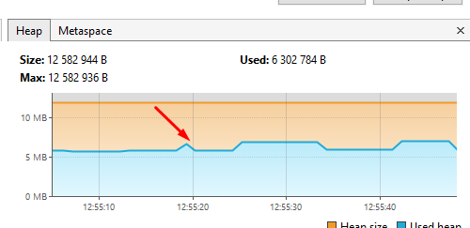

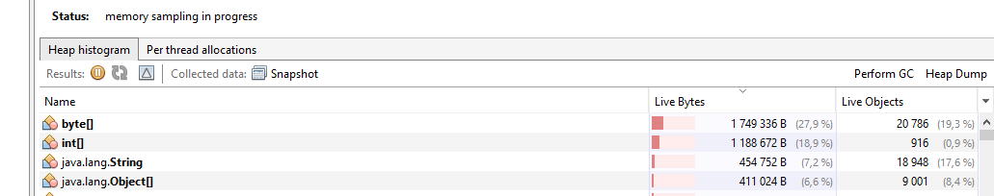

Время сортировки 28мс

MergeSort Начало сортировки - 12:55:19.299254500

MergeSort Конец сортировки — 12:55:19.585249100

**Вставка (**InsertSort**)**

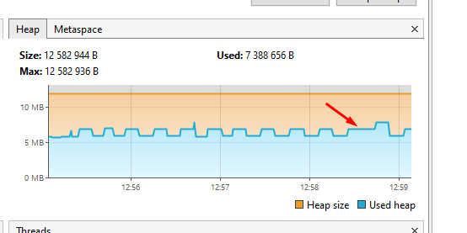

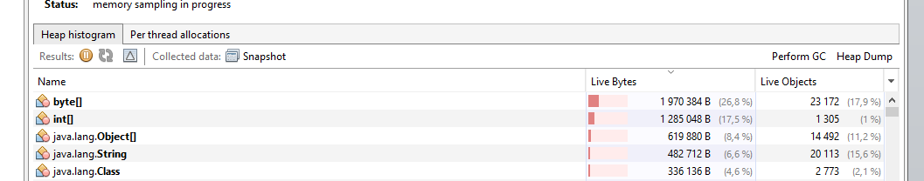

Время сортировки 11мс

InsertSort Начало сортировки - 12:58:34.548709900

InsertSort Конец сортировки - 12:58:45.244710300

**Пузырек**

Время сортировки 3.2м

BubbleSort Начало сортировки - 13:00:47.420353200

BubbleSort Конец сортировки - 13:04:19.243586300

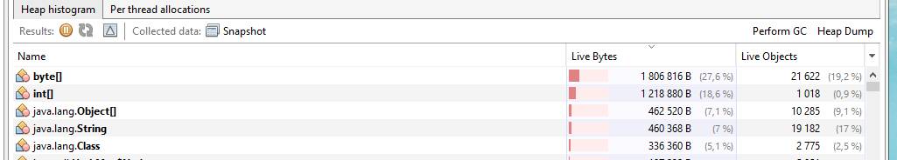

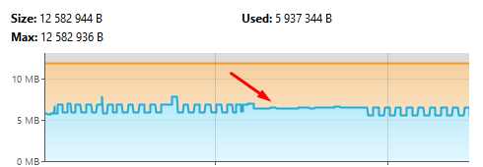

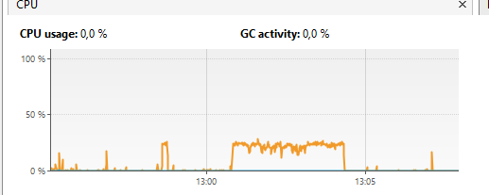

**-XX:+UseZGC -Xmx200m -Xms200m -Xlog:gc:log_Z.txt:time,level,tags**

**Слияние**

Время сортировки 30мс

MergeSort Начало сортировки - 13:32:39.380390500

MergeSort Конец сортировки - 13:32:39.627399500

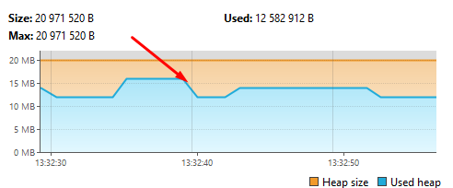

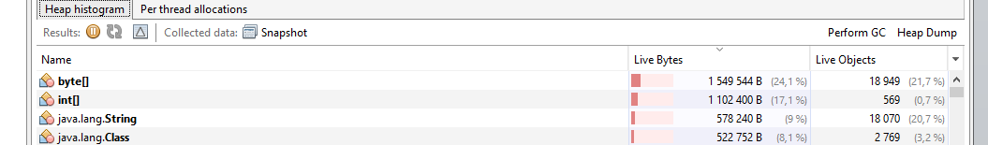

**Вставка**

Время сортировки 10мс

InsertSort Начало сортировки - 13:34:32.506822

InsertSort Конец сортировки - 13:34:42.463819800

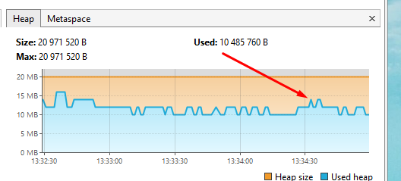

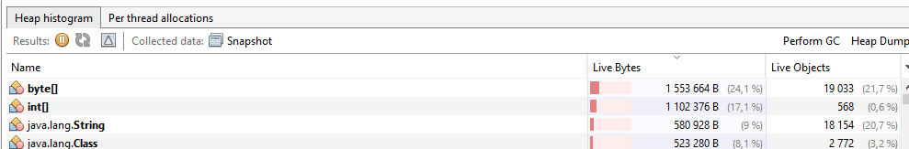

**Пузырек**

Время сортировки 3мин

BubbleSort Начало сортировки - 13:36:22.323146400

BubbleSort Конец сортировки - 13:39:08.520175

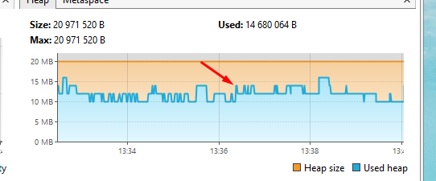

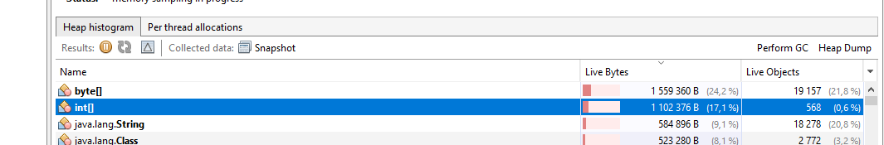

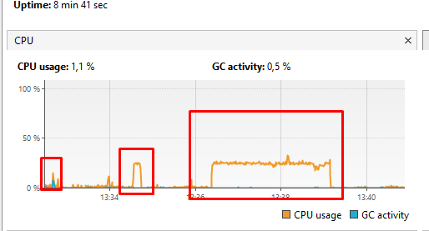

**-XX:+UseParallelGC -Xmx12m -Xms12m -Xlog:gc:log_Parallel.txt:time,level,tags**

**MergeSort 7мс**

**BubbleSort 2м**

**InsertSort 6с**

Видим малые сборки и полную сборку мусора

[2024-12-25T14:39:03.390+0300][info][gc] Using Parallel

[2024-12-25T14:39:04.048+0300][info][gc] GC(0) Pause Young (Allocation Failure) 2M->1M(11M) 5.317ms

[2024-12-25T14:39:11.744+0300][info][gc] GC(1) Pause Young (Allocation Failure) 4M->3M(11M) 6.630ms

[2024-12-25T14:39:11.894+0300][info][gc] GC(2) Pause Young (Allocation Failure) 6M->3M(11M) 3.350ms

[2024-12-25T14:39:12.026+0300][info][gc] GC(3) Pause Young (Allocation Failure) 6M->4M(11M) 6.717ms

[2024-12-25T14:39:12.114+0300][info][gc] GC(4) Pause Young (Allocation Failure) 7M->5M(11M) 5.281ms

[2024-12-25T14:39:13.669+0300][info][gc] GC(5) Pause Young (Allocation Failure) 8M->6M(10M) 5.417ms

[2024-12-25T14:39:14.078+0300][info][gc] GC(6) Pause Young (Allocation Failure) 8M->6M(11M) 4.546ms

[2024-12-25T14:39:14.403+0300][info][gc] GC(7) Pause Young (Allocation Failure) 8M->7M(11M) 2.726ms

[2024-12-25T14:39:14.427+0300][info][gc] GC(8) Pause Full (Ergonomics) 7M->4M(11M) 23.884ms

[2024-12-25T14:39:22.444+0300][info][gc] GC(9) Pause Young (Allocation Failure) 6M->4M(11M) 1.237ms

[2024-12-25T14:39:33.788+0300][info][gc] GC(10) Pause Young (Allocation Failure) 6M->4M(11M) 0.934ms

[2024-12-25T14:39:43.458+0300][info][gc] GC(11) Pause Young (Allocation Failure) 6M->5M(11M) 1.125ms

[2024-12-25T14:40:01.470+0300][info][gc] GC(12) Pause Young (Allocation Failure) 7M->5M(11M) 0.424ms

[2024-12-25T14:40:19.492+0300][info][gc] GC(13) Pause Young (Allocation Failure) 7M->5M(11M) 0.541ms

[2024-12-25T14:40:38.486+0300][info][gc] GC(14) Pause Young (Allocation Failure) 7M->5M(11M) 0.455ms

[2024-12-25T14:40:56.500+0300][info][gc] GC(15) Pause Young (Allocation Failure) 7M->5M(11M) 0.682ms

**-XX:+UseG1GC -Xmx12m -Xms12m -Xlog:gc:log_G1GC.txt:time,level,tags**

**MergeSort 7мс**

**BubbleSort 2м**

**InsertSort 6с**

Видим копирования объектов из янг в еволюшн(?)

[2024-12-23T16:40:37.979+0300][info][gc] Using G1

[2024-12-23T16:40:39.083+0300][info][gc] GC(0) Pause Young (Normal) (G1 Evacuation Pause) 4M->2M(12M) 5.765ms

[2024-12-23T16:40:46.038+0300][info][gc] GC(1) Pause Young (Normal) (G1 Evacuation Pause) 5M->4M(12M) 2.559ms

[2024-12-23T16:40:46.038+0300][info][gc] GC(2) Pause Young (Normal) (G1 Evacuation Pause) 5M->4M(12M) 1.074ms

[2024-12-23T16:40:46.038+0300][info][gc] GC(3) Pause Young (Normal) (G1 Evacuation Pause) 5M->4M(12M) 1.136ms

[2024-12-23T16:40:46.054+0300][info][gc] GC(4) Pause Young (Normal) (G1 Evacuation Pause) 5M->4M(12M) 1.210ms

[2024-12-23T16:40:46.054+0300][info][gc] GC(5) Pause Young (Normal) (G1 Evacuation Pause) 5M->4M(12M) 1.298ms

[2024-12-23T16:40:46.076+0300][info][gc] GC(6) Pause Young (Normal) (G1 Evacuation Pause) 6M->4M(12M) 1.205ms

[2024-12-23T16:40:46.076+0300][info][gc] GC(7) Pause Young (Normal) (G1 Evacuation Pause) 6M->4M(12M) 1.336ms

[2024-12-23T16:40:46.086+0300][info][gc] GC(8) Pause Young (Normal) (G1 Evacuation Pause) 6M->5M(12M) 0.955ms

[2024-12-23T16:40:46.086+0300][info][gc] GC(9) Pause Young (Normal) (G1 Evacuation Pause) 6M->5M(12M) 1.490ms

[2024-12-23T16:40:46.086+0300][info][gc] GC(10) Pause Young (Normal) (G1 Evacuation Pause) 7M->5M(12M) 1.282ms

[2024-12-23T16:40:46.086+0300][info][gc] GC(11) Pause Young (Normal) (G1 Evacuation Pause) 7M->5M(12M) 1.187ms

[2024-12-23T16:40:46.102+0300][info][gc] GC(12) Pause Young (Concurrent Start) (G1 Evacuation Pause) 6M->5M(12M) 1.144ms

[2024-12-23T16:40:46.102+0300][info][gc] GC(13) Concurrent Mark Cycle

[2024-12-23T16:40:46.102+0300][info][gc] GC(14) Pause Young (Normal) (G1 Evacuation Pause) 6M->5M(12M) 0.998ms

[2024-12-23T16:40:46.102+0300][info][gc] GC(13) Pause Remark 6M->6M(12M) 1.433ms

[2024-12-23T16:40:46.102+0300][info][gc] GC(15) Pause Young (Normal) (G1 Evacuation Pause) 6M->5M(12M) 1.019ms

[2024-12-23T16:40:46.102+0300][info][gc] GC(13) Pause Cleanup 5M->5M(12M) 0.103ms

[2024-12-23T16:40:46.102+0300][info][gc] GC(13) Concurrent Mark Cycle 7.838ms

[2024-12-23T16:40:46.102+0300][info][gc] GC(16) Pause Young (Prepare Mixed) (G1 Evacuation Pause) 6M->5M(12M) 0.742ms

[2024-12-23T16:40:46.102+0300][info][gc] GC(17) Pause Young (Mixed) (G1 Evacuation Pause) 6M->5M(12M) 1.067ms

[2024-12-23T16:40:46.102+0300][info][gc] GC(18) Pause Young (Concurrent Start) (G1 Evacuation Pause) 6M->5M(12M) 0.872ms

[2024-12-23T16:40:46.102+0300][info][gc] GC(19) Concurrent Mark Cycle

[2024-12-23T16:40:46.118+0300][info][gc] GC(20) Pause Young (Normal) (G1 Evacuation Pause) 6M->5M(12M) 1.043ms

[2024-12-23T16:40:46.118+0300][info][gc] GC(19) Pause Remark 6M->6M(12M) 0.921ms

[2024-12-23T16:40:46.118+0300][info][gc] GC(19) Pause Cleanup 7M->7M(12M) 0.151ms

[2024-12-23T16:40:46.118+0300][info][gc] GC(19) Concurrent Mark Cycle 6.553ms

[2024-12-23T16:40:46.118+0300][info][gc] GC(21) Pause Young (Normal) (G1 Evacuation Pause) 7M->5M(12M) 1.012ms

[2024-12-23T16:40:46.118+0300][info][gc] GC(22) Pause Young (Concurrent Start) (G1 Humongous Allocation) 6M->5M(12M) 0.947ms

[2024-12-23T16:40:46.118+0300][info][gc] GC(23) Concurrent Mark Cycle

[2024-12-23T16:40:46.118+0300][info][gc] GC(23) Pause Remark 6M->6M(12M) 0.889ms

[2024-12-23T16:40:46.118+0300][info][gc] GC(23) Pause Cleanup 6M->6M(12M) 0.120ms

[2024-12-23T16:40:46.118+0300][info][gc] GC(23) Concurrent Mark Cycle 4.477ms

**-XX:+UseZGC -Xmx20m -Xms20m -Xlog:gc:log_ZGC.txt:time,level,tags**

**MergeSort 8мс**

**BubbleSort 2м**

**InsertSort 6с**

Видим отсутствие пауз. Allocation Stall- запрос на больший хип

[2024-12-23T16:38:50.863+0300][info][gc] Using The Z Garbage Collector

[2024-12-23T16:38:51.040+0300][info][gc] GC(0) Garbage Collection (Warmup) 4M(20%)->4M(20%)

[2024-12-23T16:38:51.131+0300][info][gc] GC(1) Garbage Collection (Warmup) 4M(20%)->4M(20%)

[2024-12-23T16:38:52.029+0300][info][gc] GC(2) Garbage Collection (Warmup) 6M(30%)->4M(20%)

[2024-12-23T16:38:53.640+0300][info][gc] GC(3) Garbage Collection (Proactive) 6M(30%)->4M(20%)

[2024-12-23T16:38:58.233+0300][info][gc] GC(4) Garbage Collection (Proactive) 8M(40%)->6M(30%)

[2024-12-23T16:39:03.412+0300][info][gc] Allocation Stall (main) 12.399ms

[2024-12-23T16:39:03.415+0300][info][gc] GC(5) Garbage Collection (Allocation Stall) 20M(100%)->12M(60%)

[2024-12-23T16:39:03.431+0300][info][gc] GC(6) Garbage Collection (Allocation Rate) 12M(60%)->18M(90%)

[2024-12-23T16:39:03.448+0300][info][gc] Allocation Stall (main) 10.311ms

[2024-12-23T16:39:03.450+0300][info][gc] GC(7) Garbage Collection (Allocation Stall) 20M(100%)->12M(60%)

[2024-12-23T16:39:03.545+0300][info][gc] GC(8) Garbage Collection (Allocation Rate) 16M(80%)->6M(30%)

[2024-12-23T16:39:03.633+0300][info][gc] GC(9) Garbage Collection (Allocation Rate) 6M(30%)->6M(30%)

[2024-12-23T16:39:03.721+0300][info][gc] GC(10) Garbage Collection (Allocation Rate) 6M(30%)->6M(30%)

[2024-12-23T16:39:03.819+0300][info][gc] GC(11) Garbage Collection (Allocation Rate) 6M(30%)->6M(30%)

[2024-12-23T16:39:03.933+0300][info][gc] GC(12) Garbage Collection (Allocation Rate) 6M(30%)->6M(30%)

[2024-12-23T16:39:04.033+0300][info][gc] GC(13) Garbage Collection (Allocation Rate) 6M(30%)->6M(30%)

[2024-12-23T16:39:04.130+0300][info][gc] GC(14) Garbage Collection (Allocation Rate) 6M(30%)->6M(30%)

[2024-12-23T16:39:04.226+0300][info][gc] GC(15) Garbage Collection (Allocation Rate) 6M(30%)->6M(30%)

[2024-12-23T16:39:04.632+0300][info][gc] GC(16) Garbage Collection (Allocation Rate) 6M(30%)->6M(30%)

[2024-12-23T16:39:04.718+0300][info][gc] GC(17) Garbage Collection (Allocation Rate) 6M(30%)->6M(30%)

[2024-12-23T16:39:04.829+0300][info][gc] GC(18) Garbage Collection (Allocation Rate) 6M(30%)->6M(30%)

[2024-12-23T16:39:04.927+0300][info][gc] GC(19) Garbage Collection (Allocation Rate) 6M(30%)->6M(30%)

[2024-12-23T16:39:05.029+0300][info][gc] GC(20) Garbage Collection (Allocation Rate) 6M(30%)->6M(30%)

[2024-12-23T16:39:05.132+0300][info][gc] GC(21) Garbage Collection (Allocation Rate) 6M(30%)->6M(30%)